Spatial Memories Usability Report

July 2014

Contents

Usability Report 2

Resources: 2

The App 3

Current App Status (July 2014) 4

User Evaluation 6

Who we worked with 6

Evaluation results 8

Summary 8

General Usability / Workflow Issues 10

Data Capture Workflow 13

Camera App 14

Audio Recorder / Media Player 16

Maps, Tracks and Location 18

Maps 18

Tracks 19

User Location Marker 20

Location “Call Out” 21

Map View for Voice Over Users 21

Creating and Viewing Text 22

Grid and List View 22

Geo-fences (Proximity triggers) 24

Upload (Sync) 25

Authoring Tool 25

Name ideas and terminology 26

Use cases / User scenarios 27

Concluding remarks 29

# Usability Report

This report details the usability evaluation of the Spatial Memories Proof of Concept App and Authoring Tool that was developed during period from February to July 2014. We detail how we went about evaluating the App with users and what we learnt about the usability and utility of the software, in particular for people with a range of disabilities. This report is an update to previous interim report that detailed the output from our first major evaluation session in April.

# Resources:

The **Spatial Memories Authoring Tool** can be accessed at the URL below:

<http://fieldtripgb.edina.ac.uk/sm-authoring/>

Log in to some test data via Dropbox can be obtained using credentials below:

Username: [spatialmemories@gmail.com](mailto:spatialmemories@gmail.com)

Password: Spatialm3ms

Links to video of the Spatial Memories evaluation sessions and clips of the App and Authoring Tool are provided on the Spatial Memories Authoring Tool web page here:

[**http://vimeo.com/spatialmems/videos**](http://vimeo.com/spatialmems/videos)

Below are some links and descriptions to specific resources:

**Spatial Memories - How to Capture and Retrieve Memories on the Move: (5:23)** <http://vimeo.com/101730577>Shows the App being used with Voice Over enabled to give an idea how the App can be used to capture data and how memories “ping” up when you retrace your steps.

**Spatial Memories (10:06)** <http://vimeo.com/101709166> 10 minute video showing highlights from 3 day participatory workshop event in Stirling (April 2014)

**Spatial Memories – taster** (3:30) <http://vimeo.com/101706095> Shorter video summary from 3 day participatory workshop event in Stirling (April 2014)

**Record a Track (2:28)** <http://vimeo.com/101540825> Screencast showing how to use App interface to create a track.

**Using Zoom (1:10)** <http://vimeo.com/101507760>Clip of a user interacting and discussing App with Invert Colours and Zoom accessibility features.

**Using Grid View** <http://vimeo.com/101504551> (0:56) Clip of user interacting and discussing features of App

**Using Voiceover to Start a Track (1:42)** <http://vimeo.com/101392237>Clip of a Voice Over user trying out App for first time.

**Authoring Tool Animation (3:15)** <http://vimeo.com/101387208>screencast of Authoring Tool showing the track animation feature (captured on an iPad2)

# The App

The Spatial Memories App allows people to create and share GPS tracks, with images, audio and text “Memories” which ping up / buzz you (using a proximity trigger) when you retrace your steps to remind you what to look out for, what you need to do next, or just to get your bearings. It’s a simple way for people to create landmarks, reference points and routes that are meaningful to them, based on the ground truth rather than online mapping databases and routing algorithms. For a visually impaired person they might be things that just make sense to you personally: a brightly coloured shop awning or shop window display, a waste bin, a bench or sound of a pedestrian crossing, can be included in a track and then uploaded and edited.. For someone with memory or focus issues it can provide a reminder to make your way to a bus stop, when to get off, and where to go next - helping to build confidence to travel independently. While we have focused on making the App appealing to people with disabilities, we think it has universal appeal. Most people we have introduced the App to, whether they have a disability or not, come up with an idea how they might use it - from sharing your favourite walk, shopping trip, or creating your own personal guided tour of a place you enjoy and are knowledgeable about. The unique is organising your memories into a spatial narrative, a track which you can replay and revisit.

The Spatial Memories App allows people to create and share GPS tracks, with images, audio and text “Memories” which ping up / buzz you (using a proximity trigger) when you retrace your steps to remind you what to look out for, what you need to do next, or just to get your bearings. It’s a simple way for people to create landmarks, reference points and routes that are meaningful to them, based on the ground truth rather than online mapping databases and routing algorithms.

While there are many Apps with similar features (BlindSquare, MyTracks, Sandero GPS, Google Keep to name just a few), our USP is the ability to organise your Memories into a spatial narrative, a track which you can replay, adapt and share. Not just checking into a known place but creating your own places, and creating a spatial footprint of your own.

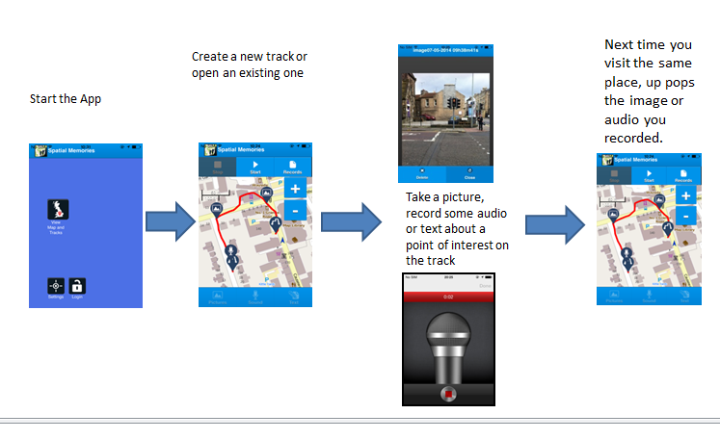Screenshots showing App Data Capture Workflow

## Current App Status (July 2014)

The most recent (July 2014) iteration of the Spatial Memories App has the following features:

Prototype App developed tested on iPhone 4(S) and above using with iOS7.

* Record a GPS track ( and capture image, audio and text ” Memories”.
* Memory pings up (with vibrate and audio cue) when you arrive in proximity
* Grid view of assets associated with each track.
* Bespoke Simple Camera App with audio and haptic feedback
* Bespoke Audio recorder with audio and haptic feedback
* Can be used with assistive tools such as Voice Over, Siri and Zoom.
* Location “Call Out” in Voice Over so users can stay informed of their current location.
* Can change colour scheme (App theme) to allow greater or less colour contrast and control features such as whether to copy captured images into the camera roll.
* Set assets to trigger iOS notifications, if App running in background.

Authoring Tool (<http://fieldtripgb.edina.ac.uk/sm-authoring/> ) with following key features:

* Supports uploading, sync’ing and sharing of records and tracks from App to Authoring Tool using a Dropbox login.
* Can view Tracks and Memories (images, text and audio notes) that user has captured on an interactive map and table.
* Can replay track using an animation that shows Memories popping up as animation progresses.
* Edit Text Memories, and add descriptive text for Image and Audio Memories
* Add new Text Memories to an existing track.

See Resources section above for links to video clips <http://vimeo.com/spatialmems/videos>

Some screenshots illustrating some of the above features are shown below:

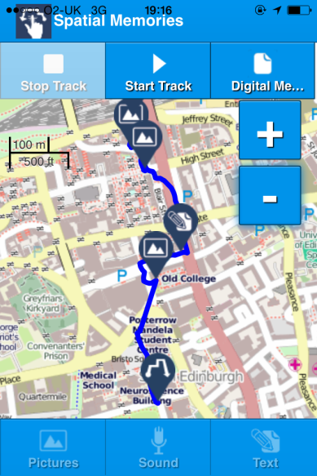 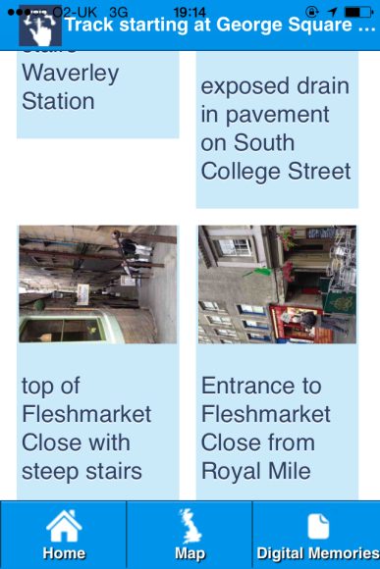 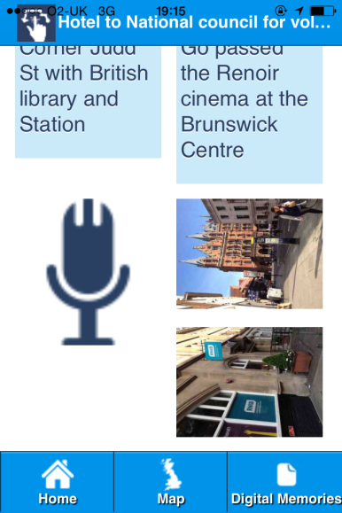

App screenshots of Map View with Track and Memories visibile, and Grid View..

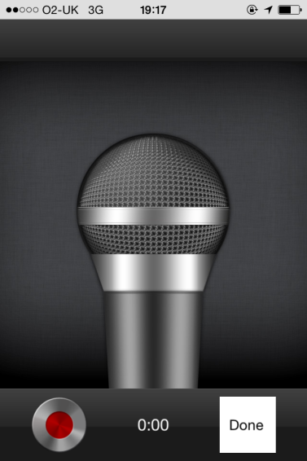 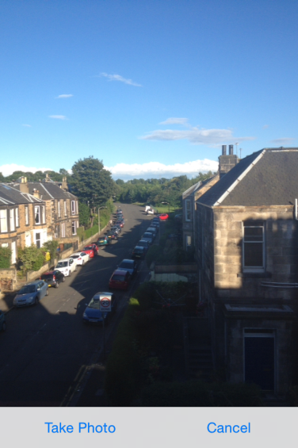 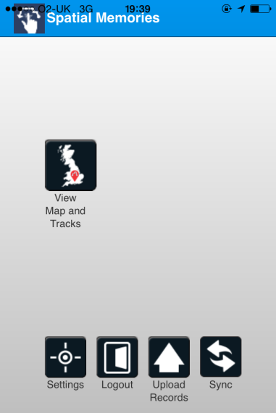

App Screenshots showing Audio recorder, Camera Viewfinder and Home Screen

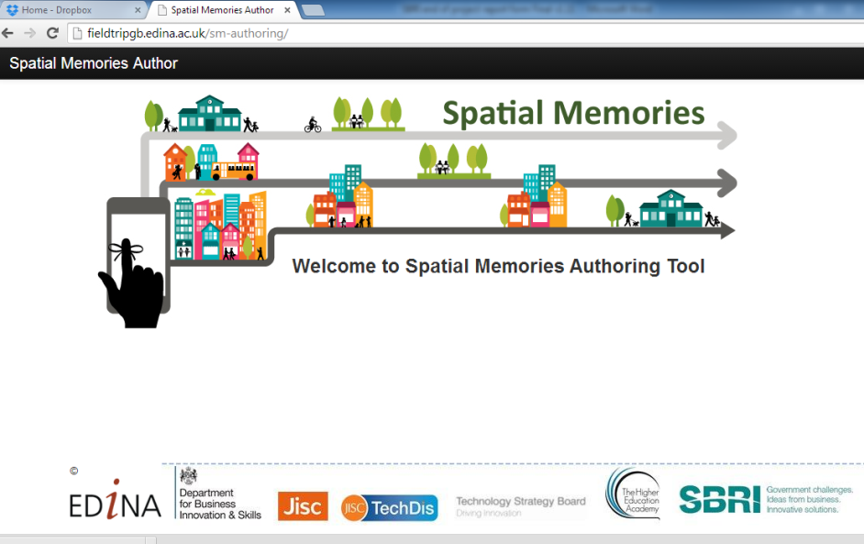

Screenshot Authoring Tool Home Page

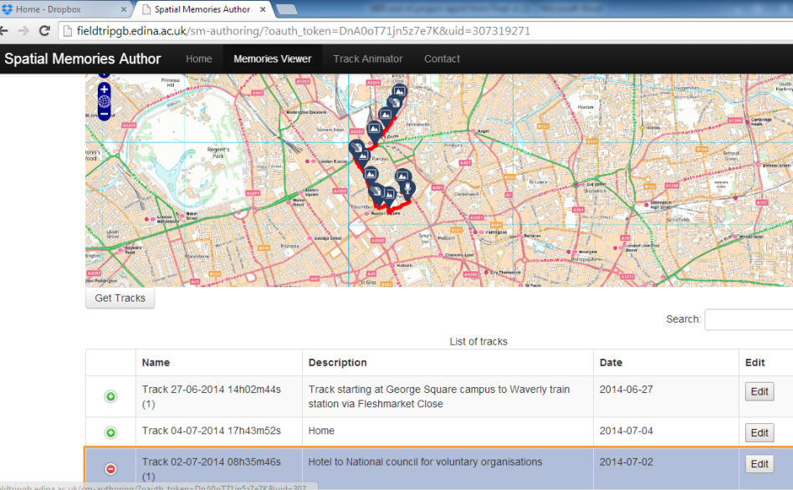

Screenshot Authoring Tool Memory Viewer

# User Evaluation

## Who we worked with

As documented in Interim Usability Report, in April we held a 3 day participatory design event in Stirling with an Artlink Central group (<http://www.abruptencounters.com/> )of 10 individuals with broad range of disabilities from autism, partial sight, focus and memory issues, Downs, epilepsy and motor coordination problems, some living independently, some in supported housing, with an age range from 17 to 70.

The participant event was great for evaluating an early baseline version of the App and generated lots of information on usability issues and ideas for subsequent development. However, we found it was difficult to evaluate the App with such a large group together, especially a group with such a large range of abilities. In particular we were not able evaluate navigation or cover a large geographical area. Tasks set for the group as a whole were too general to evaluate real world use cases. We needed to test with users in their everyday setting to evaluate usefulness of concept as the prototype developed. Therefore we organized five follow up sessions with three individuals (two group sessions and three one-to-one sessions) from the Artlink Central group taking place in June. One challenge we faced was that none of these users owned or used smartphones themselves. So, at the first meeting we gave them each a device to take home for 10days to familiarise them with the technology. We then accompanied each of them on a journey that was personal to them (such as the journey from their home to city centre), to get an idea how they might use the App in everyday settings and locations.

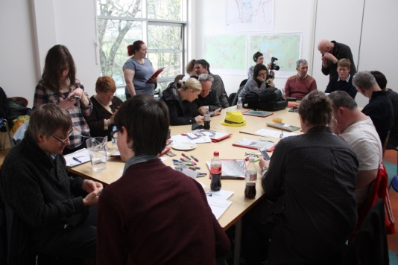 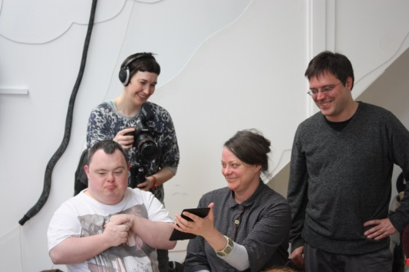

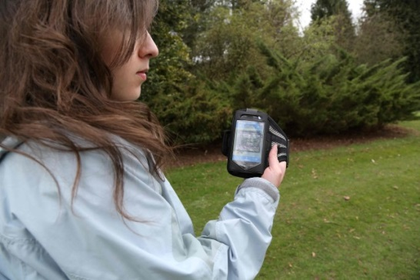 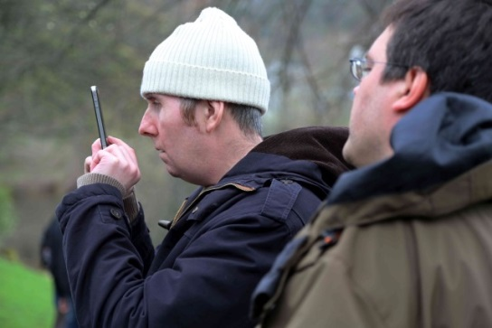

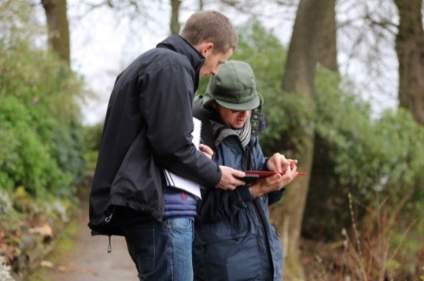 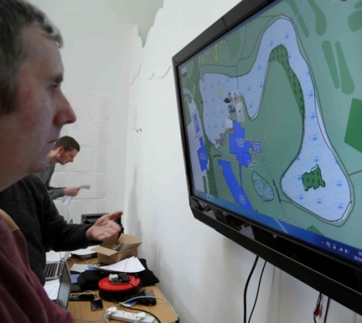 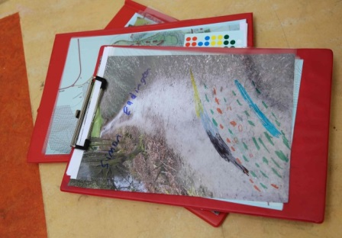

Selection of still images from Stirling Workshop in April 2014.

From May we started working with two visually impaired students from Glasgow, both very familiar with using iPhones. One user is blind and uses Voice Over all the time, while a second user who is visually impaired, uses Zoom, Inverted Colours and also uses Voice Over for reading long passages of text. We met with the two volunteers three times and were able to test successive versions of the App in controlled conditions. As the two learners had their own device we were also able to obtain some feedback from them on using the App on their own initiative. Some video clips of these evaluation sessions can be found at <http://vimeo.com/spatialmems/videos> (“Using Zoom”, “Using Grid View”, “Using Vocie Over to Start a Track”).

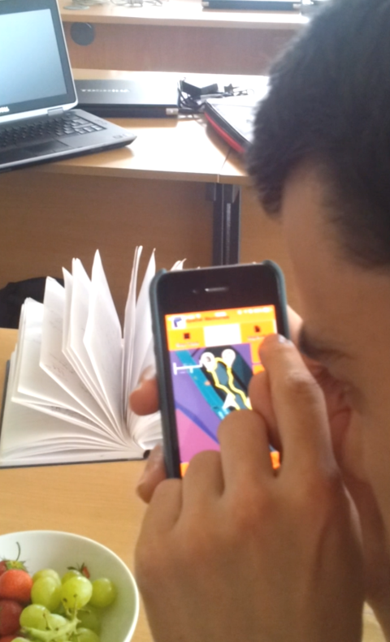 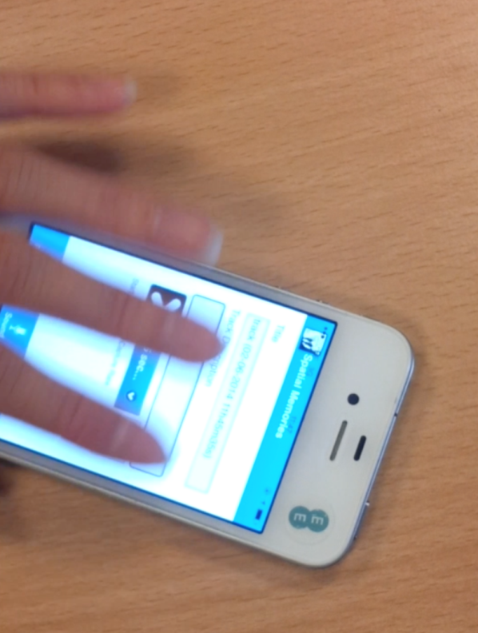

Video still of user interacting with App using Invert Colour (left) and with Voice Over (right)

In June we made contact with a work placement support co-ordinator for students with mild to moderate learning difficulties from Edinburgh College. Her role is to speak to students on  
an individual basis and find out the types of work placements they are interested in and then to source a placement for the student and support them through the placement. Although it was too late to trial with students (as term breaks up in mid-June in Scotland), we demonstrated the App to her and colleagues in her team. We were then able to discuss how the college might use the App, potential benefits and obstacles which we report on below.

## Evaluation results

### Summary

We were able to establish the technical feasibility of the App. GPS tracking and geo-fences (proximity triggers) work well in most outdoor environments, including on buses, trains and taxis. After feedback from users we managed to get the latest version of our prototype to work with assistive technologies such as Voice Over, at least to the extent that the main functions are accessible enough to be evaluated by users.

Working with the Artlink Central group we were able to demonstrate that a range of users with different disabilities can make some use of the App independently – at least in controlled conditions. We did have some issues due to user’s unfamiliarity with smartphone devices, such as accidently deleting the App from the device or not having experience to make use of assistive features such as Voice Over or Zoom. We were able to obtain a lot of useful information on usability issues with the latest version of the App and see if improvement we made since the workshop in April had made any difference ( see section below for specific functionality and enhancements that were tested).

Despite our efforts to test in everyday settings and familiarise the group with devices, it has been difficult to establish for the Artlink Central group participants how the App and Authoring tool would be relevant to their everyday life and we have struggled to generate compelling use cases for helping the individuals concerned access training and work. We found these users considered the App more as a creative tool - for example creating a “guided tour” of places and routes they were familiar with and knowledgeable about already. While it is good to see the enthusiasm and enjoyment the participants got out of the App, and generally using smartphones independently, we have to conclude that the App is not currently that relevant for their everyday agenda. In retrospect, it might have been better to provide the Artlink Central group with Smartphones from the very beginning of the project and provide some training in general Smartphone usage for several months, so that a smartphones became an everyday part of their life, ahead of running evaluations of the prototype.

two learners we worked with who have visual impairment, we were able to establish the App is of potential use to them in supporting general way-finding and independent travel . Both users were certainly enthusiastic, especially when we revisited a track we created together and geo-fences “pinged” up. We also generated a few dozen change requests and obtained excellent design ideas from these users, some of which we have already implemented and some of which we have marked for future iterations. The main challenge we had in testing the software with these users was a technical one of making the software work well with assistive technologies such as Voice Over (the technical issues are described in the Technical report accompanying this one). Testing the App with these users for the first time was certainly a wake up call and we had to go back and rethink many assumptions – particularly about how Voice Over users would want to interact with the map. An extract from one user’s comments about the second iteration gives a flavour of the quality of feedback we obtained.

“On opening the app, there seems to be a banner saying "Spacial Memories"  
this banner seems to be a heading level one. I am not too sure if you would need to have this banner? It is also a landmark. Perhaps just have the other information such as the settings etc on the page-so that the screen is not too cluttered. The next thing that appears when I am swiping towards the right of my screen (this is another Voiceover gesture), is "Main, view maps and tracks" which is a link as well as being a landmark as well as being an image. There seems to be repetition of the previous item which comes next. It simply says "View maps and tracks" but it does not seem to do anything.”  
And so it continues…Generally, every interaction with these users created a large amount of data for us to process and loads of fresh ideas about improvement we could make to the App.

From discussions with a work placement officer and other support staff at Edinburgh College, we were again able to generate use cases around improving student’s ability and confidence to travel independently to both college sites and work placements.

“We have in the past had students with Visual problems and the app would be  
of great use to them in encouraging their independence by getting to their  
work placements unaided. We have also had students with poor memory  
retention and the app would be good for them.”

Generally it was felt that this kind of technology could “opens up doors” as work opportunities would “not be restricted to a placement in a small area”.Obviously this remains somewhat speculative at the moment as students were not around to trial the App in June, but it is certainly encouraging and we believe having this contact will greatly assist us to evaluate the App in college and work placement settings in future.

One of the biggest things we learnt is that it is difficult to evaluate unfinished, buggy software with end users who already face a number of challenges interacting with smartphone interfaces due to their disabilities. Users tend to place to blame for things not working properly on themselves rather than lay blame on the incompleteness or poor design of an early software iteration. We also learnt that working with users who are not using smartphone technology in their daily lives creates an obstacle for evaluating the usefulness of a concept. In future we would provide users with smartphones from the beginning, and run workshops that encourage users to make use of smartphones generally before even showing them the software we are working on. This might mean fostering long term relationships with groups that span individual projects and software evaluations. Developing assistive technology does not seem to favour a rapid prototyping methodology but rather an iterative approach, which allows a product to evolve over a period of time. Even for users who are using smartphones all the time, to make software work well with assistive technologies such as screen readers, the software has to be of a reasonably high quality and tested in advance. There is a tension then with a rapid proto-typing methodology and the need to produce consistently high quality software that will actually be usable by someone who is blind or visually impaired.

As a result of our interaction with users in this project, we now have a far better understanding of how disabilities such as memory and focus issues, fine motor co-ordination and visual impairment can create problems for users interacting with our interfaces. Engineers involvement in user design session created much better awareness for engineers about the importance of designing for all, and ensuring code is written so it can work properly with assistive technologies such as screen readers,

### General Usability / Workflow Issues

#### Issues from baseline App evaluation

In our previous evaluation report (Interim report) we picked up several usability issues which we subsequently attempted to address. Below we review progress on these issues.

1. Several users struggled to consistently perform short tap gesture needed to activate touch screen buttons, instead holding down button for a longer period (over a second).

We have implemented a long tap gesture into the main interface and noted a difference in users’ ability to activate these buttons. However we noticed that the “native” parts of the App – buttons in the Camera and Audio Recorder interfaces for example - still presented the short tap problem. This inconsistency lead to confusion about how long users were expected to hold down buttons , so we found ourselves having to direct the users in how to operate. d. It is pretty clear that we must ensure consistency in the way the interface handles gestures across the entire application.

1. Sunlight glare was an issue for many users, especially when using the Camera.

We have not made much progress on this as evidenced by the very bright conditions for the evaluation sessions we conducted in June. We did try using the iOS “Inverted Colours” with a partially sighted user but, if anything visibility was worse. We still have scope to add more Colour Scheme options to the 3 already available and see if any of these improve visibility in bright conditions but ultimately we are probably dependent on Apple and Google to resolve this issue at a hardware /operating system level (see technical report for discussion).

1. Cancel (“X”)user buttons on image, audio and text popups were too small for many users.
2. The image popups were difficult to see for some of the participants with poor or impaired sight. In a popup window it was not possible to zoom the image.

We have changed the popup completely now so that they occupy the full screen with large delete and close buttons.

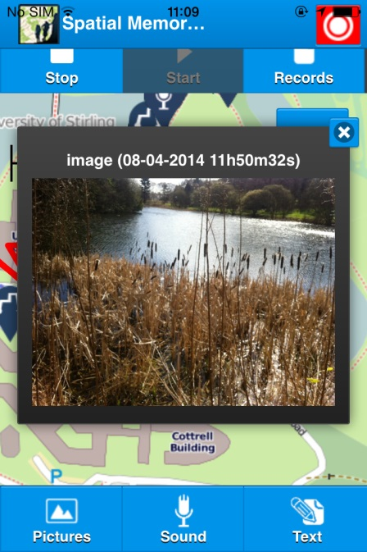 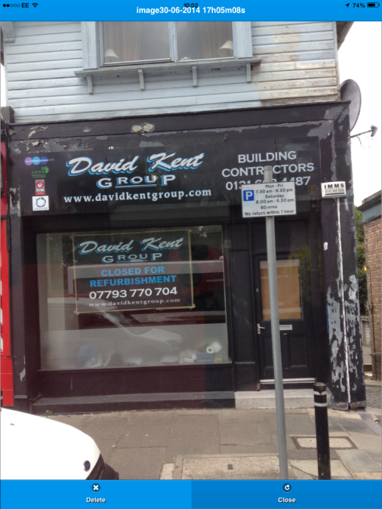

Screenshots showing image popup in early version (left) and latest version ( right). The image now occupies much larger area and delete button is more accessible.

Potentially we could still improve on this by adding a Zoom feature. However, as platforms such as iOS have built in “Zoom” accessibility features, we still need to ascertain whether it would be worthwhile implementing this in addition to built-in feature.

#### Colour and Styles

One user we worked with tested the App using the iOS Invert Colour accessibility feature. An interesting observation he made was that some maps work better than others. The map style we were using was acceptable and street names readable against background street fill, but other map Apps he uses can cause problems. He pointed out that sometimes using Invert Colours to improve the main content (in this case the map) can cause problems with visibility of other parts of the interface. So there is a case for having an Invert Colour function for the App, independent from the global invert colour settings. We also learnt that our “Water” colour theme was not providing high enough contrast for a visually impaired user. A darker blue colour scheme was evaluated and provided much better contrast for this user, so we have added this as a preference in the Settings page.

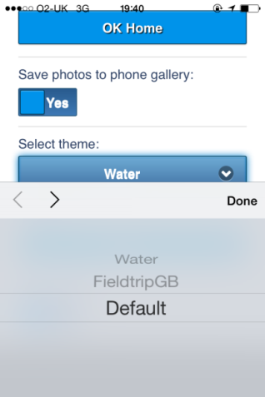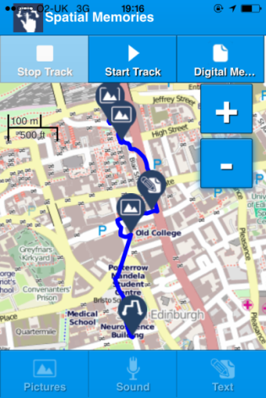 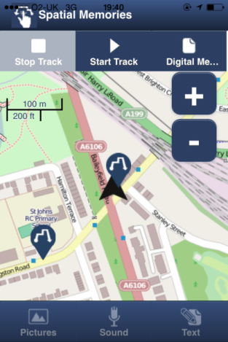 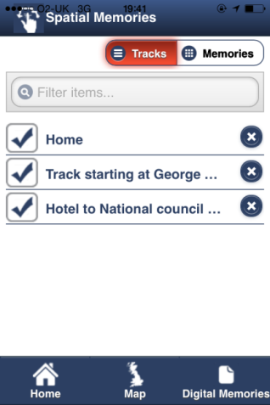

Screenshots showing Settings Page(far left). Map View “Water” Colour scheme, (left of center), Map View and Tracks list with higher contrast “Fieldtrip GB” colour scheme preferred by visually impaired user, (right of center)

#### Voice Over

We were fortunate to have two users help us evaluate the App using the iOS Voice Over screen reader. (see video “Using VoiceOver to start a track” at <http://vimeo.com/spatialmems/videos> ) Details are given on various individual parts of the App below, but one general issue we had was that labels for buttons and form elements such as dropdowns were being read out separately to the item they described. This created a very confusing effect where buttons were announced twice by Voice Over, causing user to activate the label rather than the button. This was one that proved much trickier than imagined to correct (see technical report).

Another general observation is that some tension exists between keeping data capture workflow simple and quick and having opportunity to provide some meaningful text for the screen reader. In the current version of the App, we took away the form that was presented to users before taking a photo or audio recording as we noticed that users rarely added a description before taking their photo / audio recording. Our users themselves suggested a nice solution (not implemented yet) where the description could be shown underneath the image or audio when the Memory pops up or is selected from the Grid View. The user can swipe to the description before reaching the “Delete” or “Close” buttons, and has an ongoing opportunity to add some descriptive text. Alternatively descriptive text can be added in the Authoring Tool.

Our Voice Over user also mentioned it would be useful for navigation to have “Back” and/or “Home” button on each screen. We are considering whether this should be a feature of a special “Voice Over” profile or is generally a good idea for all users.

## Data Capture Workflow

As a result of evaluation during the Stirling workshop in April, we decided to make the steps involved in capturing images, audio and text as simple as possible.

In our existing “Fieldtrip GB” app, to take an image the user must follow the workflow:

1. Click the image capture button.
2. A form opens up where the user can enter a name for the image. (e.g. “Lecture Theatre 2”)
3. The user can optionally enter a longer description.
4. The user clicks the Camera button – the Camera Viewfinder now opens.
5. The user presses the Camera shutter button to take a photo.
6. The Camera app shows the user a preview of the photo.
7. The user selects “Use” to confirm they want to use the photo.
8. The user is shown a preview of the image and a map preview showing where GPS has located the user position with a “balloon” icon indicating the captured location.
9. The user can move the balloon / pin icon on the preview map to correct any GPS inaccuracy.
10. The user confirms the positioning of the record by clicking a “Save” button and the image capture is completed.

In Spatial Memories, the process is greatly simplified.

1. Click the image capture button.
2. Press the “Take” button
3. The photo is taken and popup appears
4. Press “Close” button on the pop up Screen

While this simplifies the process and makes the data capture as quick as possible there are two drawbacks.

1. There is no opportunity to add metadata such as a description to the image. This can be added later using the Authoring Tool, but immediate effect is that there is no alternative description for image and audio Memories. This is particularly important for Voice Over users.
2. If GPS signal is not accurate at the time of data capture there is no way to correct it.

Discussing the first issue with Voice Over users, one user came up with a clever solution (not implemented yet) where the description could be included as a field in the pop up that appears immediately after the image or audio is captured, or when it is selected from the Grid View. The user then has an option of adding a description. The second issue is harder, but we think we have implemented a strategy to reduce the likelihood of incorrect GPS fix being associated with the captured data. In recent iterations we start a continuous location update (every 5 seconds) as soon as the App starts up and display a location marker as soon as a reliable fix is obtained. As the GPS track is an ongoing process repeatedly obtaining location updates from the operating system, a good location fix should already be obtainable by the time a user seeks to create an image, audio or text memory. This workflow should also align better with the operating systems location strategies where typically less accurate methods are used to obtain an initial location, allowing time to obtain fixes on satellites needed for more accurate location updates. Generally it appears this new strategy is working well as we have not had problems with location fixes since this implementation.

## Camera App

In our Interim Usability report we noted usability issues with workflow of accepting a taken photo using the default Cordova camera App. The preview image in the corner part of this was often not noticed so users did not realise they had successfully taken an image. When asked whether they wanted to “Use” or “Retake” the photo, users often mistakenly pressed “Retake” and were confused as to why nothing appeared to change. Users also found that they were switching to front facing camera (unintentional selfie) or video mode.

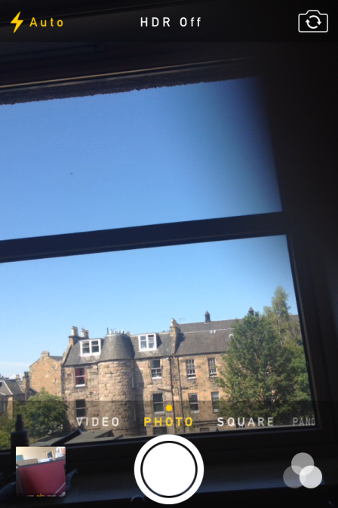 

Screenshot of original Camera (left) and Simple version we created (right)

As a result of this feedback, we implemented a much simpler Camera App with just two buttons (“Take” and “Cancel”). In both cases the Camera Viewfinder is closed after the button is pressed and returns immediately to the main “Map and Tracks” screen with audio and vibrate feedback. When a photo was captured the Image pops up in (full screen) so there is no doubt in the users mind a photo has been taken (see images below). As the pop up has a large “Delete” button, it is possible to discard the image taken at this point if it is not what the user wanted. Otherwise the user can click “Close”. Our evaluation with Artlink Central group members demonstrated that these improvements worked reasonably well but we still have a few issues to sort out. The two Camera buttons are not very high contrast (grey and blue text) so are hard to make out for partially sighted user. Another user found the choice presented in the popup image after the photo is taken confusing, perhaps because of the words used. Offering a “positive” vs. “negative” option might help users to contrast the options being offered (e.g. “Keep” / “Delete” instead of “Delete” / “Close”

 

We also learnt that copying images captured to the Camera Roll is an irritation for users who have visual impairment as they have to rely on memory, to keep track of which photos they have in their camera stream. Images copied over from other Apps can upset their expectations. For other users though, we have established that it is useful to be able to see the images from the App in the Camera stream as this is their familiar way of viewing photos. After discussing some options with users we implemented this as a toggle in the App Settings page. In addition we have tested the Camera with Voice Over to verify the buttons are all accessible.

## Audio Recorder / Media Player

As described in the Interim Usability report, the biggest issue for audio recording and playback was volume control. Many users found that the playback was too quiet even when device volume set to high. Also the interface was too subtle to provide adequate feedback for some users that recording was in progress.

Testing audio features in June with visually impaired users (for whom audio is often a preferred option) opened up a whole new can of worms. In Voice Over, the sequence of buttons traversed using a right swipe gesture was not in any way helpful, starting with a “Done” button (even though no recording taken place yet) and then displaying the recording counter before finally getting to the “Record on / off “button. There was no audio indication that recording was in progress and after recording was complete (again no audio / haptic feedback) navigating backwards to the Done button to save the recording was very confusing. The Audio playback interface also had an issue where the counter (counting seconds into playback) was read out by voice Over, drowning out the audio playback itself.

We also observed working with individual Artlink Central participants in June, that the toggle record on / off button was sensitive and easy to press twice when intending to press just once. This was a serious usability issue as the recording is overwritten if you start a new recording before saving the existing one. One user who made a very long audio recording was disappointed and confused to lose the recording after he pressed the toggle button twice.

To deal with all these issues we decided to re-design both the audio recorder interface and the audio playback.

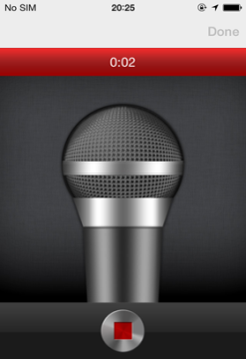  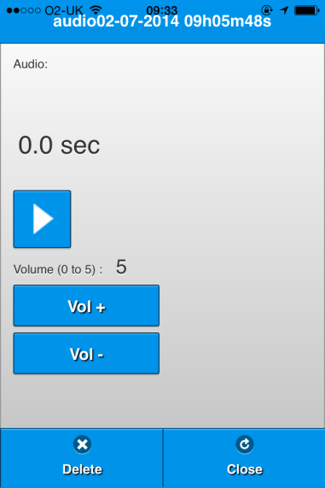

Screenshot of first Audio recorder interface (left) and latest version with button reorganised (middle) and the audio playback screen with volume control (right).

The audio recorder (currently being evaluated) has the following enhancements in progress.

1. Focus initially set on “toggle audio recording” button
2. Right swipe gesture (in Voice Over mode) goes first to Timer (showing length of recording) and then the “Done” button. (note need to have better contrast for “Done” button)
3. An audio tone (similar to answer machine) to denote recording started and ended.
4. We are considering if record toggle button should be replaced with separate “record” and “stop” buttons to avoid the accidental double press of the toggle button.
5. Also considering adding stronger visual feedback to signify that recording taking place such as ON AIR light.

The audio player (currently being evaluated) has following enhancements implemented or planned.

1. Timer counter ignored by Voice Over during playback.
2. Volume control buttons added so user can make recording louder if necessary.

Another issue we noted with Audio s is that when making a recording it is tempting to use instructions such as “turn left after the flower shop”. But when the Memory pops up when following the track in the opposite direction, it will give an entirely incorrect direction.

We also noted that it is difficult for users to remember to hold the microphone close to their mouth when making an audio recording. This has a big effect on playback volume. One idea might be to use the device proximity / accelerometer sensors to trigger the recording to start, or warn user to speak into microphone.

One of the Artlink Central participants we worked with attempted to use the audio recorder in a way we had not anticipated at all. His expectation was that the audio would work more like a Dictaphone so that he could make a continuous long lasting audio track as he strolled around an area of interest. The expectation was that the audio track would sync with the GPS track, so parts of the same recording would be triggered by a series of proximity triggers rather than a single discrete trigger that marked the point where the recording was initiated (or stopped). While beyond the capabilities of the existing proof of concept, this is an intriguing way to think about the process of recording an audio sequence linked to a track. We might want to consider how this could be implemented – for example, automatically cutting an audio track into segments if a user is detected to have moved a certain distance from the start point. This does provide a good example of how participatory design and evaluation can generate novel ideas – especially when working with creative people.

## Maps, Tracks and Location

### Maps

During the 3 day Stirling workshop we worked with participants on a number of activities to evaluate map styles, cartographic design and symbols. Details are outlined in our Interim Usability report. .

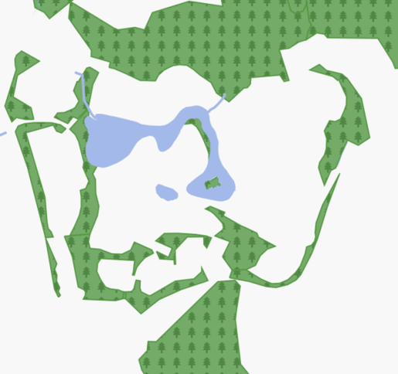 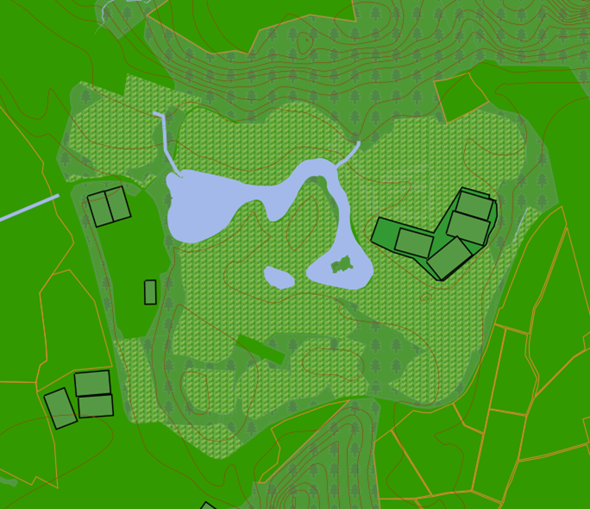 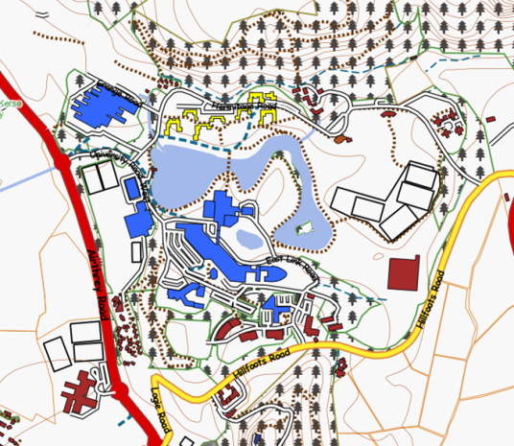 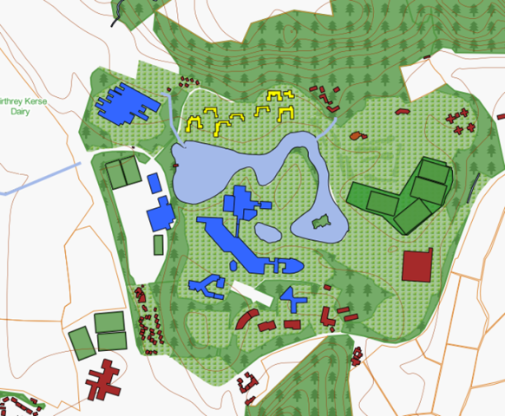

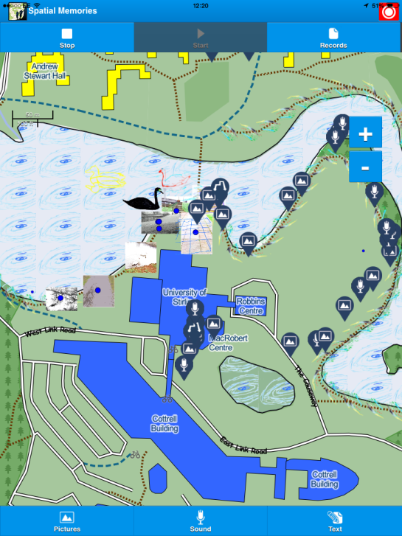

Some example maps showing different layering of features and symbols from Stirling workshop

We envisaged originally that some users might prefer different cartographic options and map styles, but abandoned this idea after our April design sessions, as it was clear that users did not have strong individual or disability driven preferences for map styles. (although we found some evidence to the contrary later in project when evaluating the App in June with a visually impaired user). Similarly, with user generated symbols we found that the map quickly became too crowded or symbols were not as clear as pre-designed abstract symbols. The notion of turning a photo or sketch into an abstract design is potentially a rich visual research topic.

### Tracks

One of the main enhancements we made to the Map and Track interface since the workshop in April was to make the track the central design concept, ensuring each Memory is associated with a single track. Initially the map only shows track marker icons (one for each recorded track), while hiding image, audio and text markers. When the user touches a track icon it displays the track on the map along with the Memory markers associated with that track. Similarly the Grid View only shows the Memories associated with currently open track. This helps to reduce clutter in the Map and reinforces the tracks as the core concept in the interface.

  

App screenshots of Map View with Track and Memory icons, and Grid View showing Memories for track in 2d tile format.

Generally users were fairly comfortable with the process for recording tracks. It was clear that users do not find it intuitive to start recording a track before they can create Memories. However, once this workflow once was explained, most users got the idea, and as Pictures, Sound and Text buttons are disabled until a track started, users were reminded as soon as they wanted to create something new.

Both visually impaired users we worked with however requested some kind of feedback when track recording starts. And we noticed that other users (with no visual problems) required confirmation that they were in process of recording a track as the GPS line takes a while to start and also needs the user to move some distance before seeing the line begin to grow. So both an audio and visual cue for indicating that track recording in progress would be a useful enhancements. One further change we made was to make adding a description for each track mandatory to ensure some the descriptive text could be shown in the track list view, and also provide something for the screen reader (Voice Over).

### User Location Marker

One problem we noted in the earlier version of the App was that users did not know where they were when retracing a track. This was because we initially only had continuous location tracking activated when the user was recording a track. The App now continually tracks the device location and shows the location maker at the user’s current position all the time. We also have implemented a large location icon with high contrast to assist users with visual impairment. Also the map automatically pans to the current location so that the location maker is always at the centre of map when user is recording a track. While this auto panning behaviour is useful when in process of recording a track, it can create problems when the user simply wants to browse the map and view the tracks on the map. If the user tries to view a track in a different location to their actual location they will see the expanded track and icons for just a few seconds before the map snaps back to the current user position. On the other hand, when a user is actually in the process of following a track that they recorded previously, it is useful for the map to place the location maker in the centre, especially for people with poor sight. Also for Voice Over, the “Location Call Out” feature is useful to obtain contextual information whether or not recording a track. We discussed a few options with users after evaluating the App and came up with following suggestions:

1. Have an “Auto Pan” toggle button in Settings page.
2. Have some way to make an existing track “active” (see related idea in geo-fence section below) and auto pan map if you are currently in proximity of a track.

### Location “Call Out”

A nice feature we added on the suggestion of a Voice Over user was an audio replacement for the location marker which we dubbed “Location Call Out”. This feature works in conjunction with Voice Over screen reader. Whenever the App updates the current user location, it looks up a text description of area (e.g. “Downing Street, Westminster” ) depending on the current zoom level.

While there is a similar feature in the latest version of Apple Maps App, this requires the user to swipe to the location marker first, and traverse through multiple streets and geographic features before the location maker description is found. Users described this as “information overload” and suggested all they really would need is for the system to call out the position of the location marker as their location changed, just to get a general context of their journey. The “Call Out” feature seems to meet this requirement but we are still in process of evaluating this with users as it is a recent addition to the App.

### Map View for Voice Over Users

The first time we witnessed Voice Over users interacting with Map screen was a revelation and we found we needed to sort of a multitude of issues before we could get anything meaningful out of the evaluation.

For example:

* Every tile in the map had its randomly generated file name read out (something like “1345423449433434.jpg”)
* The scale bar was read out.
* The zoom buttons were not properly labelled (plus / minus rather than zoom in / zoom out).
* No way to quickly get to the 6 most important buttons (“Stop recording track” ,”Start Recording Track”,” Create Audio”, “View Memes”, “Create Text”, “Photo” etc. ) without first traversing every map tile and scale hints and zoom buttons.
* Buttons that were inactive for users using Touch, could nevertheless be activated in Voice Over mode, breaking the workflow.
* The 3rd party AJAX colour picker in the “Track Colour” field in Start GPS track was completely nonsense in Voice Over ( the dropdown arrow was amusingly read out as “little pointy down arrow” - so we left it in for a while before replacing the whole widget with a simple dropdown selector)

We initially envisaged that users would touch explore the map so we put some effort into making the Memory Icons on the map have appropriate alternative text – such as description of type of Memory (image, Audio, Text) and added the alternative text “tile image” to each map tile, making sure the icons were marked as buttons. While this was an improvement, it soon became clear that our Voice Over user was not interested in touch explore interaction with our map ( an awakening moment occurred when we saw the user holding iPhone at 45 degree angle sideways and use map merely as a convenient touchpad for making swipe gestures). We later improved things greatly by making map tiles presentational only, so these images were completely ignored by Voice Over, allowing easier swiping between other elements in the page. We settled on a mode where swiping would start at first button “Stop” and then tab through main buttons – “Start”, “Digital Memories”,” Take Photo”, “Make Audio”, “Make Text”.

## Creating and Viewing Text

The main modification we made to Text Memories was simply to increase the font. As for images the popup now fills the full screen so there is plenty of space for larger passages of text. We still need to provide different colour contrast according to selected style as this is not implemented yet. Text is a useful for Voice Over users, especially as new Memories can be added to a track using the Authoring Tool. We did have some concern as to whether Voice Over users could easily create long passages of text. At the suggestion of a user, we tested using Siri Voice-To-Text feature in iOS (iPhone 4S and above) and were pleasantly surprised how effective this was. Although Siri will usually have some errors its much faster than typing on a small screen ( especially with Voice Over ) and as the Authoring Tool offers an opportunity to post edit the text later, it provides an effective workflow for capturing text quickly and editing later.

It was pointed out to us that the pre-populated title field in the Text entry form was confusing in Voice Over, as there was no indication that this field was already populated. For a Text Memory, users suggested it is better to either hide the title field altogether, and/or skip straight to the description field.

One user from the Artlink group was very keen to persevere with Text and entered a long passage using the small iPhone keyboard. At home, he uses an electric typewriter, so he was used to taking some time to key in text. Although we suggested the text could be edited later he wanted to get It perfect and spent some time correcting errors. This suggests that it might be worthwhile allowing users to edit Text after the Memory is created in the App as well as in the Authoring Tool.

## Grid and List View

In our Interim report we noted the issues below with Grid and List View,

1. While Text Memories can be previewed by including a first part of the note, the Grid View does not offer a way for users to distinguish between different Audio Memories.
2. List View was not that useful as users did not change default record names.
3. As users generally did not change the name of the record from the default, titles displayed for each tile in Grid View were not useful and created clutter.
4. It is not clear whether tracks should be shown in the Grid View at all it is not obvious what the equivalent of an image thumbnail would be.
5. Delete (“X”) buttons are too small for many users with fine co-ordination issues ( or just big fingers) to action.
6. Consideration is required on how to preview Audio and Track notes in both the Grid and List View.

In line with suggestions from Interim Usability report we have introduced larger Icons for Audio and larger font text to give the Grid View a more balanced appearance and make it easier to access these records. We have now replaced the list of records with a list of tracks and implemented behaviour where selecting a track opens the Grid View and shows just the records for that track. If the user provides a text description for the Audio we can show this below the icon. What might work is to have a “Play/Preview” button as well as the microphone icon which could play the first few seconds of the audio without leaving the grid view to provide a preview (not implemented yet).

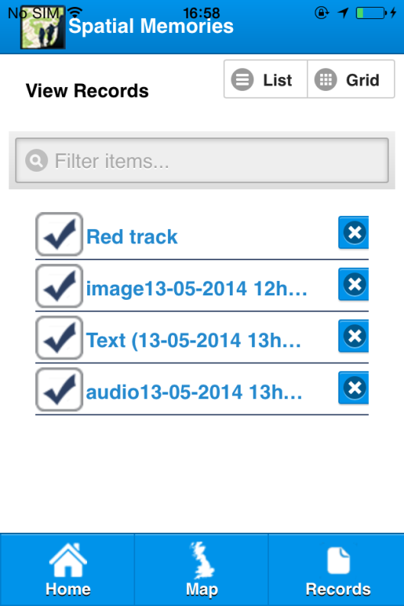 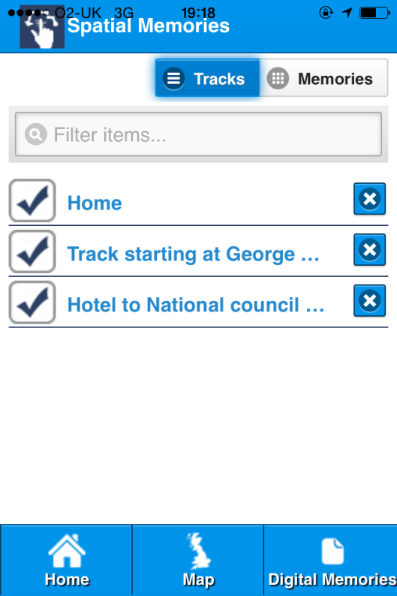

List View changes: previous version (left) listed all records, current version only shows tracks.

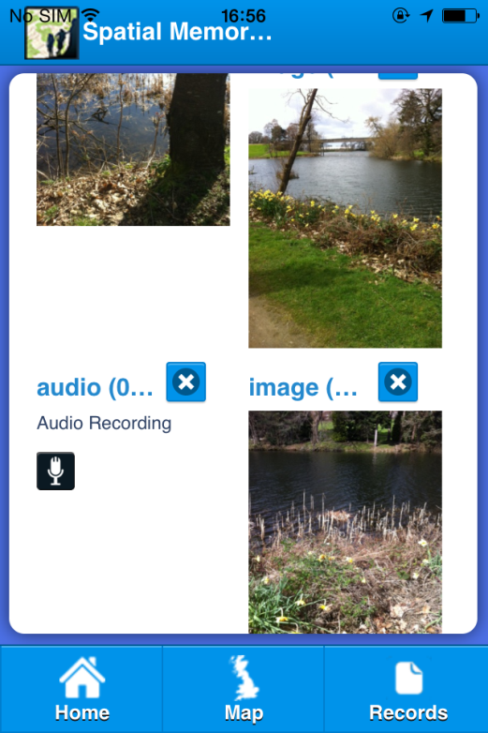 

Grid View changes: previous version (left) and current version (right)

One user involved in our evaluation suggested we make more of the track list. He was disappointed that selecting a track from the list only showed the Memories for that track in the Grid View. He suggested that it should also be possible to activate and de-activate tracks in the list so that geo-fences could be switched on/off and to view the track in the map. We certainly would like to explore this idea and we think it would be interesting also to experiment with an animation, similar to the one implemented in the Authoring Tool for replaying a track. (see “Authoring Tool animation” <http://vimeo.com/spatialmems/videos>).

## Geo-fences (Proximity triggers)

We now have geo-fences working reliably for Text, Audio and Images Memories having ironed out bugs that were present in baseline App (see Interim Usability report). An important addition is adding audio and haptic (vibrate) feedback when geo-fence triggers. We have generally found users are somewhat startled but delighted by “ping” noise and pager vibrate.

User comments from group discussion session (April workshop) was very encouraging with a lot of positive feedback and relevant comments on this feature of the user experience. Some examples of observations user made:

“Exciting when photos popped up”

“A good way to keep track of memories because [I’m] not so good a note taking”

“Seeing pictures stirred memories. It made you think more about what you [saw?] so you could come back and revisit your route…Memory was stirred into reliving moment”

“More relaxed – aided concentration”

“Primed something else in your memory”

As these comments suggest, it was certainly clear users enjoyed the novelty of images popping up and this helped to trigger memories from previous day. The default proximity of 20 meters works well for pedestrian travel which has been focus of our evaluation work to date. It also confirmed that geo-fences work well on buses and trains, but we might need to consider triggering the alert at a greater distance when travelling faster asIt might already be too late on a bus trip if a Memory is triggered as you’re already passing your bus stop.. Thr alternative is to allow user to specify the radius of the geo-fence but we think it is best to keep the interface as simple as possible and let the technology decide when to activate a geo-fence (see technical report for discussion).

Geo-fences now can be triggered when the App is in background or screen locked. In this case, an iOS notification is triggered (typically with audio and haptic cue) which the user will see when unlocking the device and can swipe the notification to open the App with the activated Memory popping up. (this is a new feature currently being evaluated).

A great Idea suggested by our Voice Over user was to have different audio tones (other than ping) announce different Memory types. On creating a Text for example, a user could choose from a selection of sounds to reference bus stops, waste bins, drop curves, steps. This would allow the user to keep the phone in their pocket as geo-fences are triggered and simply use the different sounds to demark different objects in a soundscape.

As discussed in previous section, another user came up with a further suggestion of making geo-fences active only when track is active.

## Upload (Sync)

The data users collect (GPS tracks and image, audio and text Memories) must be uploaded to a server in order to be accessed and edited by the Web based Authoring Tool. Similarly, changes and new Memories added in the Authoring tool need to be sync’d back to the App. The current implementation uploads and syncs via Dropbox (<https://www.dropbox.com/home> ). However it should be noted that our design is not closely coupled to Dropbox or any other Cloud Storage Provider. Eventually we expect that Spatial Memories will have its own cloud storage. Generally sync seems to work well but we have noticed some occasional problems where images belonging to one track get mixed up with another one. Another issue is the accessibility of the user login to Dropbox. This is something that is not in our control as we pass over to the Dropbox authorisation page when the user enters their credentials. We also have noticed a significant delay before the page loads up which is particularly problematic for Voice Over users.

## Authoring Tool

The Authoring Tool is still being actively evaluated so we have limited information on its usability at the moment. There are 3 main features in the current interface.

<http://fieldtripgb.edina.ac.uk/sm-authoring/> (log in [spatialmemories@gmail.com](mailto:spatialmemories@gmail.com) / Spatialm3ms)

1. An interactive Map and Table which shows Tracks and Memes.
2. An Animation which allows users to retrace their steps (literally!).
3. An interface which allows users to create a location file (partially implemented) by specifying the bounding box of the area for which locations should be generated.

It is designed in a similar way to the Map View in the App.

1. User first has to log in (via Dropbox at the moment although we expect to replace this shortly with our own cloud storage provider).
2. User selects “Get Tracks” which shows a list of the tracks user has uploaded to the Cloud.
3. This shows tracks and Meme icons on Map and also lists them in table.
4. By selecting a track in the table the table is expanded to show the Memories for the selected track and also the GPS track is displayed on the map with icons for each Memory.
5. Users can view and edit an individual Memory, by clicking “Edit” and changing the description field.
6. Users can add a new (Text) Memory to the track.

The Animation Tab allows users to:

1. Select a track from list of tracks and start animation running,
2. For every Memory a popup appears. User can choose let animation continue or have it pause to view each Memory before resuming animation..

## Name ideas and terminology

We asked a number of users for their opinion on what we should call the App as well as canvassing opinion from engineers and others working on building and evaluating the App. Below are some of the options that were discussed:

Spatial Memories

Digital Memories

Memory Tracks

Memory Trails

Mem(e)Tracks

Mem(e)Trails

Memory Lines

Spimey

Memory Spear

Spime Lines

Spime

TrackMem(e)

Map my mind

MindNav

NavBrain

MyBrainMap

ReminderMapper

Locus Meme

ClickCam

PicApp

Ping

Users seemed to fall into 2 camps. One camp liked MemoryLines or MemoryTrails, but users with visual impairment there was a preference for “MindNav” or “Map my Mind”. Although quite a small sample, this does suggest a difference in the way users perceive the App, depending on how they think they might use it, with one group focusing on the App as a tool for creating a narrative, and the other group focusing on mental models for supporting way-finding and navigation.

Another naming issue to resolve has been how to collectively describe the media elements, image, text and sounds that we had initially called “Digital Memory” or “Memory”. We did use word “Digital Memory” within in the App itself (both in text and Voice Over) but users didn’t appear to pick this up to the extent of using it themselves. Users generally used familiar terms for the individual media elements like image, audio and text.

With regard to the Artlink Central group we worked with, the “Memory” concept was not especially how they viewed the App. They appeared to engage with the App more as a creative tool i.e. life logging or story-telling tool rather that the practical recall purposes we had in mind at outset of project. Also, the visually impaired users engaged with it more as a navigation / way finding tool rather than a memory aide.

## Use cases / User scenarios

As a result of feedback from users following our evaluation, the expected benefit of the Spatial Memories concept has shifted from the original notion that focused primarily on helping learners remember activities and routines within the immediate area of a workplace / college to focus on way-finding and independent travel to and from places of training and learning.

From discussions with a work placement officer and other support staff at Edinburgh College, we were able to generate use cases around improving student’s ability and confidence to travel independently to both college sites and work placements.

“We have in the past had students with Visual problems and the app would be  
of great use to them in encouraging their independence by getting to their  
work placements unaided. We have also had students with poor memory  
retention and the app would be good for them.”

Generally it was felt that this kind of technology could “opens up doors” as work opportunities would “not be restricted to a placement in a small area”

Obviously this remains somewhat speculative at the moment as students were not around to trial the App in June, but it is certainly encouraging and we believe having this contact will greatly assist us to evaluate the App in college and work placement settings in future.

The individuals from the Artlink Central group we worked with saw the App as a creative tool for recording a kind of “guided tour” of places that they wanted to communicate about to others.

Some thoughts on benefits, which have come from the two visually impaired users we worked with are as follows:

1. A user who is about to move to new accommodation discussed using the App to create a series of tracks with relevant waypoints and navigation reminders that would help him navigate from his new home to known locations and destinations such as college, favourite social places such as cafes. The greatest potential benefit the App offers for him over other solutions is the ability to create landmarks that are relevant to him, such a brightly coloured shop awnings or window displays.
2. The same user liked idea of using the Authoring Tool to offer a way to add more detail to a captured record after returning home. So having captured the location of a bus stop using the App, he could later add in timetable information when at home using the Authoring Tool.
3. One suggestion was that the App could be used with a support worker to help establish a new route which might be needed when starting a work placement or new job. So a support worker might accompany a user on a route the first time and after this initial orientation, it would be possible to use the App to capture reference points such as waste bins, curbs, steps and other street furniture that would help establish the route as something the user could later revisit themselves.
4. Another use identified was to create a track or tracks with instructions covering the places friends go to socialize such as pubs. Being able to create a track during daytime, or requesting friends on Facebook planning to meet up somewhere create and share a track from a known location to the destination, would make finding the places friends go easier, especially at night time and enable meeting friends socially more spontaneous.
5. A user who is about to do work as volunteer for the Commonwealth Games suggested using the App to create accessible routes and transport links between events.
6. A user who is currently seeking a new rented apartment explained he has to post a message on Facebook asking if any friends could accompany him to a viewing. We discussed how friends living nearby could take a detour and use the App to create a track and reference points which he could then follow independently.

Another application suggested by inclusion officers and experts in assistive technology, is to use the App for crowd sourcing accessibility issues, such as temporary road works and low hanging branches. It was suggested that if the App had a share feature, users could make use social networks to let people aware of problems and alternative routes.

## Concluding remarks

We have developed a proof of concept App and web based Authoring Tool, which we have demonstrated can be used by people with visual impairment, memory and focus problems and other disabilities. The feedback we have received so far encourages us to believe that it will help people to travel independently and make it easier to negotiate an unfamiliar route and to share routes and landmark / reference points with other users and friends.

We have gained a lot of experience and knowledge from working directly with users, both understanding how to design better for making software accessible, but also how to involve users effectively in our design and evaluation process.

We have also established some important contacts with individuals and volunteer groups (some at the later stage of the project) including Jisc Regional Support Centre in Glasgow, work placement and support team at Edinburgh College, Site Scotland, which will help us greatly going forward. With the effort we have put into making the interfaces accessible, the proof of concept App now gives us a concrete offering we can use to interact with groups and volunteers to get better understanding of how App can be used.